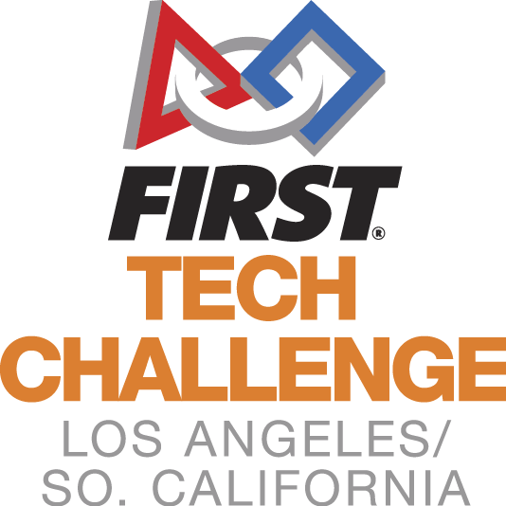 Welcome to the
LA/SoCal FIRST® Tech Challenge
Monrovia Zone C Inter-League Tournament
Leagues A1 and C2
February 9, 2019

WELCOME TEAMS! The LA/SoCal Committee looks forward to your participation in the upcoming LA/SoCal FIRST® Tech Challenge Inter-League Tournament! Below is some additional information to help you prepare. Please read to the end of the document as there is helpful information for you.

EVENT LOCATION
The tournament will be held at Monrovia High School in Monrovia, CA, which is located north of the 210 Freeway between the 110 and 605 Freeways. (If you have any problems the day of the event, please call or text Miriam at (626) 841-1956)
Monrovia High School
845 W. Colorado Blvd.
Monrovia, CA 91016

DIRECTIONS
From Highway 210, take exit 33 (Huntington Drive), turn right onto Huntington, turn right onto 5th, turn right onto Colorado, turn left on Madison. The school is located on the corner of Colorado and Madison.

PARKING
Enter the school using the driveways off Madison Ave. There will be a ‘drop off loop’ for cars to stop and drop off robots at the front of the Event Center. After drop off, please park in one of the designated areas (see map and look for signs).

GENERAL INFORMATION
The competition will take place in the Event Center (northwest side of the property off of Madison). The Pit will be set up also at the Event Center. Judging will be in the science building (south of the Pits). The competition area and the Pit are spacious.
We will be running a 30-team One-Division tournament with 2 fields on site. All teams from each League are invited to their appropriate ILT and there are no eliminations at this point. At the ILT, there will be engineering notebooks to hand in, all the judging categories will be awarded, Compass and Promote Videos will be open, and Dean’s Award candidates will be recognized.
If you have accumulated game points from League meets, it will come into play for ILT Alliance selections. At the ILT, 10 of your top 15 matches will be in the scoring system.. At the end of the ILT Qualifying matches, your 5 scores will be added to the scoring system. The highest total of these points from the 15 matches will determine the top alliance captain, next alliance captain, and so on.
The top teams (as determined by the Game Manual advancement criteria) will advance to the Los Angeles Championship Tournament. These teams will be announced on the following Robot Tuesday.

TENTATIVE SCHEDULE (which may shift based on day’s events)
SUNDAY
7:00 AM Volunteer Check-In
7:30 AM Pits and Check-In Open
8:00 AM Judging, Robot and Field Inspections begin
8:00 AM Check-In Closes
9:30 AM Driver Meeting
10:00 AM Opening Ceremonies
10:30 AM Qualifying Matches Begin
12:00 PM Lunch
12:30 PM Qualifying Matches Resume
2:30 PM Alliance Selection
3:00 PM Semi Final Matches Begin
5:00 PM Awards Ceremony
6:00 PM Event ends (tentative time)
6-8:00 PM Clean-up/Set up for Sunday

TEAM CHECK-IN
Check is between 7:30 am and 8:00 am. All teams MUST check in by 8:00 am or they will not be given qualifying matches. Please note – The judging and inspection schedules are pre-assigned and start prior to the end of check-in. You must check in prior to your scheduled judging or inspection time slot.

Bring to check-in:
- FTC Consent form for each team member, mentor and parent. We highly recommend completing the consents by registering for an account at http://www.firstinspires.org (Benefit? You don’t need to collect forms – only print the roster of completions!)
*Coaches, Log into your account. Your dashboard has a “youth members” button. From there you can print your roster (printable roster button)
- Bring your engineering notebook. If you are competing for the Control Award, please fill out the form and have it with your Engineering Notebook. NAME and TEAM NUMBER needs to be on the front cover.
- Safety glasses for your team (Have them out and ready before entering the Pit Area). If you are in the pit or competition areas, safety glasses are required. Prescription glasses must have ANSI certified side shields or safety glasses over them. (Duct tape or paper attached to the side of glasses is not sufficient.) Please have them for your visitors as well or ask them to bring their own if they plan to see you in the PIT.
- Bring your filled in Robot Inspection and Field Inspection Sheets (Game Manual #1, Appendix B and C).
- Hard copy picture of your team and robot (this can be a Polaroid, a flyer, or any other document that will help the judges remember you). Place photo in the engineering notebook.

Please wear closed toe shoes and eye protection. Closed toe shoe are required for both the Pit Area and Competition Area, so without them you will not be able to enter most of the facility. We ask all team members to wear closed toe shoes all day. If visitors are planning to see you in the PIT, they should be wearing closed toed shoes and eye protection as well.

INSPECTION (PLEASE READ)
Inspections will begin at 8:00am. Teams will be pre-assigned a timeslot, emailed no later than January 28th.. Do not miss your timeslot. If you do, we cannot guarantee that you will get through inspection prior to the start of matches. You may not compete without a completed inspection.
A copy of the Inspection Checklists that will be used can be downloaded from https://firstinspiresst01.blob.core.windows.net/ftc/game-manual-part-1.pdf Appendix B and C. Please review these prior to coming to the event to ensure that your Inspection process goes smoothly.

JUDGING
Judging interviews will begin at 8:00am and end by Opening Ceremonies. Teams will be pre-assigned a timeslot, included in this document. Should there be any changes, these will be emailed to you at least one week prior to the event. Do not miss your timeslot. All of your team members are welcome to attend the judging interview, just remember the time is 10 minutes and manage your time appropriately. NEW – LAST YEAR: A team can, but is not required to, have up to a 5 minute rehearsed presentation to share with the judges. This would be part of your 10 minute interview. If you do not want to give a practiced presentation, the judges will ask questions as they have in the past during the 10 minutes.
One mentor or coach can accompany the team at the judging interviews, but only to view the process, not to interact. The judges will also be visiting the Pit as part of the judging process, and it is recommended you always have a team member at your booth.
Submit your Compass and Promote Nominations by Midnight, one week before the event (No later than February 1st, 2019, 11:59pm)
The format is YouTube with a link provided. link provided.

VOLUNTEERS
As with the League play, each team has a commitment to supply volunteers. For the ILT, we need 2 volunteers per team. The Volunteer Room opens at 7:00 am (see on map). Please check the volunteer assignments to see what time you need to check in. A separate Volunteer letter will be sent out.

KEY DATES
January 28, 2019 – Look for email with Pre-Assigned Inspection and Judging Schedule
February 1st, 2019 – Compass and Promote Submission due before Midnight
February 9th, 2019 – Competition Day!!!

SEE JUDGING SCHEDULE AND MAP IN FOLLOWING PAGES FOR MORE DETAILS

Judging Times - ILT 2/9 Monrovia A1-C2 - SATURDAY |  |  |  | Jessie Klemme- Judge Advisor
Time | Panel 1 | Panel 2 | Panel 3 | Panel 4 | Panel 5
 | Judges:
8:00 - 8:15 | 9512  HippieBots | 9513  System Overload | 9881  Golden Gears | 9887  RoboVikings | 10674  RavenRobotics
8:15 - 8:30 | 11546  BWS Eaglets | 11770  Curiousity | 11825  Graveyard Shift | 12997  Cosmos | 13125  Brentwood Eaglebots
8:30 - 8:45 | 13705  Hillcrest Robotics | 14917  Asteria | 15157  IFC | 15161  SaMoVar | 15532  Stardust Engineers
8:45 - 9:00 | 25  RocknRoll Robots | 542  WHS Robotics | 3526  Marlbots | 4153  Droidnaughts | 4512  West Torrance Robotics
9:00 - 9:15 | 4625  King and Queens | 4628  Suitbots | 4947  Cougarobbotics Alpha | 5218  Javabots | 5390  Vikings
9:15 - 9:30 | 5498  Cougarobotics Omega | 6570  Piradians | 7553  Team Loki | 8624  Spectrum | 9324  BWS Eagles
9:30 - 10:30 | deliberations | deliberations | deliberations | deliberations | deliberations
10:30 Opening Ceremonies

SEE MAP IN FOLLOWING PAGE FOR MORE DETAILS
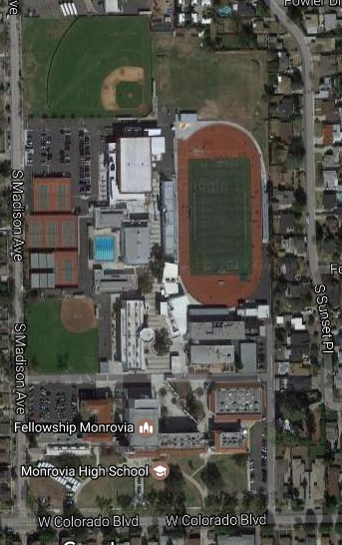
Monrovia High School
845 W. Colorado Blvd, Monrovia CA 91016
Event Center: Competition and Pits
Robot Drop Off and Registration
Parking
Parking
Volunteer Lounge
Science Building: Judging

