Welcome to the
LA/SoCal FIRST® Tech Challenge
Palmdale Inter-League Tournament
Leagues D and V
Saturday, February 16th, 2019

WELCOME TEAMS! The LA/SoCal Committee looks forward to your participation in the upcoming LA/SoCal FIRST® Tech Challenge Inter-League Tournament! Below is some additional information to help you prepare, please read to the end of the document as there is helpful information for you.

EVENT LOCATION
We will be competing at The Palmdale Aerospace Academy in Palmdale, CA. Located east of the 14 Freeway. The school is on the corner Palmdale Blvd and 35th Street East.

The Palmdale Aerospace Academy
3300 East Palmdale Blvd
Palmdale, CA 9355

If you are late or have any problems the day of the event, please call Patrick @ 951-232-2272.

DIRECTIONS
NOTE: Construction is happening on the west side of campus. There is a chance the north entrance will be closed or we have a different drop-off spot. There will be campus supervisors directing traffic so please follow them.

From Highway 14 North - Exit Palmdale Blvd and go east. The school is on the right between 30th and 35th east.

From Highway 14 South - Exit Avenue S and go east. Turn left on 35th East. Drive until Palmdale Blvd and the school will be on the left.
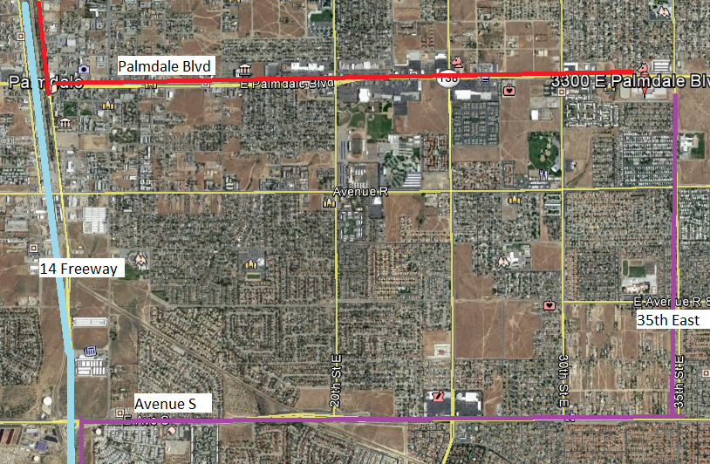

Parking & Drop off
Park anywhere in the TPAA parking lot. You can drop off team stuff in the drop-off loop on the south side of campus. (Picture is out of date. Construction is done)
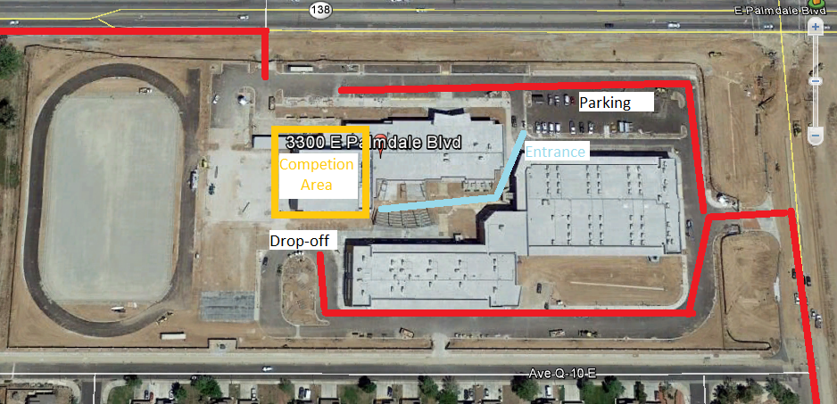

GENERAL INFORMATION
The competition will take place in the gym. The pit and practice area will be set up in the cafeteria. Inspections will be in the gym. Judging rooms will be in the T building on the south side of campus. We try to maximize the amount of space teams have in the pit, but we expect it to be very busy, especially in the morning.
Please remind team members and your spectators to be patient and gracious.
We will be running a 21-team One-Division tournament with 2 fields on site. All teams from each League are invited to their appropriate ILT and there are no eliminations at this point. At the ILT, there will be engineering notebooks to hand in, all the judging categories will be awarded, Compass and Promote Videos will be open, Dean’s Award candidates will be recognized.
If you have accumulated game points from League, it will come into play for ILT Alliance selections. At the ILT, 10 of your top 15 matches will be in the scoring system. At the end of the ILT Qualifying matches, your 5 scores will be added to the scoring system. The highest total of these points from the 15 matches will determine top alliance captain, next alliance captain, and so on.
The top teams (as determined by the Game Manual advancement criteria) will advance to the Los Angeles Championship Tournament. These teams will be announced on the following Robot Tuesday.
Please verify your team name in your Team Management System with the Inspection/Judging Times provided in the email. If there is a discrepancy, please email TFKlemme@gmail.com.

TENTATIVE SCHEDULE (which may shift based on day’s events)
SATURDAY
7:00 AM Volunteer Check
7:30 AM Pits and Check-In Open
8:00 AM Judging, HW and Field Inspections begin
8:00 AM Check-In Closes
9:30 AM Driver Meeting
10:00 AM Opening Ceremonies
10:30 AM Qualifying Matches Begin
12:00 PM Lunch
12:30 PM Qualifying Matches Resume
2:30 PM Alliance Selection
3:00 PM Semi Final Matches Begin
5:00 PM Awards Ceremony
6:00 PM Event ends (tentative time)
6-7:00 PM Clean up / set up for Sunday

TEAM CHECK-IN
Check is between 7:30 am and 8:00 am. All teams MUST check in by 8:00 am or they will not be given qualifying matches. Please note – The judging and inspection schedules are pre-assigned and start prior to the end of check-in. You must check in prior to your scheduled judging or inspection time slot.

Bring to check-in:
- FTC Consent form for each team member, mentor and parent. We highly recommend completing the consents using the following link: www.firstinspires.org (benefit? You don’t need to collect forms – only print the roster of completions!)
- Coaches Log into your account, Your dashboard has a “youth members” button, from there you can print your roster (printable roster button).
- Bring your engineering notebook . If you are competing for the Control Award, please fill out the form and have it with your Engineering Notebook. NAME and TEAM NUMBER needs to be on the front cover
- Safety glasses for your team (Have them out and ready before entering the Pit Area) If you are in the pit or competition areas, safety glasses are required. Prescription glasses must have ANSI certified side shields or safety glasses over them. (Duct tape or paper attached to the side of glasses is not sufficient.) Please have them for your visitors as well or ask them to bring their own if they plan to see you in the PIT..
- Bring your filled in Field Inspection and Robot Inspection Sheets (game Manual #1, Appendix B and C) .
- Hard copy picture of your team and robot (this can be a Polaroid, a flyer, or any other document that will help the judges remember you) Place photo in the engineering notebook.

Please wear closed toe shoes. These are required for both the Pit Area and Competition Area, so without them you will not be able to enter most of the facility. We ask all volunteers to wear closed toe shoes all day. If visitors are planning to see you in the PIT they should be wearing closed toed shoes as well.

INSPECTION (PLEASE READ)
Inspections will begin at 8:00am. Teams will be pre-assigned a timeslot, emailed to you no later than (January 14, 2019). Do not miss your timeslot. If you do, we cannot guarantee that you will get through inspection prior to the start of matches. You may not compete without a completed inspection.
A copy of the Inspection Checklists that will be used can be downloaded here. Robot inspection and Field inspection. Please review these prior to coming to the event to ensure that your Inspection process goes smoothly.

JUDGING
Judging interviews will begin at 8:00 am and end by Opening Ceremonies. Teams will be pre-assigned a timeslot, emailed to you at least one week prior to the event. Do not miss your timeslot. All of your team members are welcome to attend the judging interview, just remember the time is 10 minutes and manage your time appropriately. NEW - LAST YEAR: A team can, but is not required to, have up to a 5 minute rehearsed presentation to share with the judges. This would be part of your 10 minute interview. If you do not want to give a practiced presentation, the judges will ask questions as they have in the past during the 10 minutes.
One mentor or coach can accompany the team at the judging interviews, but only to view the process not to interact. The judges will also be visiting the Pit as part of the judging process and it is recommended you have a team member at your booth always.
Submit your Compass and Promote Nominations to link below by Midnight, one week before the event (No later).
The format is YouTube with a link provided.
VOLUNTEERS
As with the League play, each team has a commitment to supply volunteers. For the ILT, we need 2 volunteers per team. The Volunteer Room opens at 7:00 am (see the map). Please check the volunteer assignments to see what time you need to check in. A separate Volunteer letter will be sent out.

KEY DATES (PLEASE READ)
January 15th 9pm - Deans List Candidates due
January 25 , 2019 – Look for email with Pre-Assigned Inspection & Judging schedule
February 8, 2019 – Compass and Promote Submission due before Midnight
February 16, 2019 – Competition Day!!!

JUDGE TIMES
Time | Panel 1 | Panel 2 | Panel 3 | Panel 4
 | Judges:
8:00 - 8:15 | 4348  RoboKnights | 5889  Cyberians | 5942  Team Torch | 6282  Simi Valley Robotics
8:15 - 8:30 | 8415  ANCroid | 8894  Clueless Robotics (Team ADHD^2) | 9247  Chromium Robotics | 9894  RoboLions
8:30 - 8:45 | 10006  Spudnik | 10298  Brain Stormz | 10673  Spudbot | 11167  Verdugo Hills High School Robotics
8:45 - 9:00 | 11683  RoboKnights Too | 12675  Hermit Social Club | 13046  BugByte Robotics | 13646  CHS Robotics
9:00 - 9:15 | 13978  Mechanized Garbage | 14312  Huerta | 14801  Tigeroids | 15429  Extremophiles
9:15 - 9:30 | 11385  ChidoriBots | 11386  Anon0mous | deliberations | deliberations

INSPECTION TIMES
8:00 - 8:30 AM |  | 8:30 - 9:00 AM |  | 9:00 - 9:30 AM
10006 | Spudnik | 4348 | RoboKnights | 9247 | Chromium Robotics
10298 | Brain Stormz | 5889 | Cyberians | 9894 | RoboLions
10673 | Spudbot | 5942 | Team Torch | 12675 | Hermit Social Club
11167 | Verdugo Hills High School Robotics | 6282 | Simi Valley Robotics | 13046 | BugByte Robotics
11683 | RoboKnights Too | 8514 | ANCroid | 13646 | CHS Robotics
14312 | Huerta | 8894 | Clueless Robotics (Team ADHD^2) | 13978 | Mechanized Garbage
14801 | Tigerdroids | 11385 | ChidoriBots
15429 | Extremophiles | 11386 | Anon0mous

