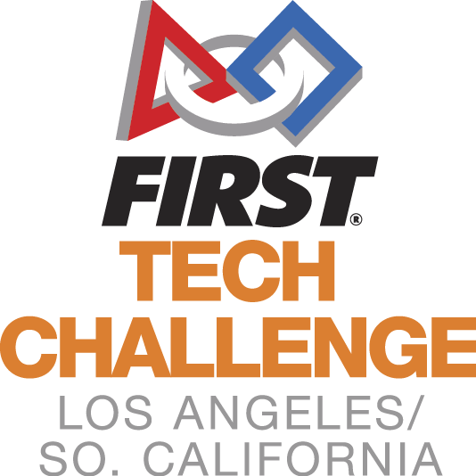
Welcome to the
LA/SoCal FIRST® Tech Challenge
Palmdale Inter-League Tournament
Leagues A2 and I
Sunday, February 17, 2019

WELCOME TEAMS! The LA/SoCal Committee looks forward to your participation in the upcoming LA/SoCal FIRST® Tech Challenge Inter-League Tournament! Below is some additional information to help you prepare, please read to the end of the document as there is helpful information for you.

EVENT LOCATION
We will be competing at The Palmdale Aerospace Academy in Palmdale, CA.
The Palmdale Aerospace Academy
3300 East Palmdale Blvd
Palmdale, CA 93550

If you are late or have any problems the day of the event, please call Patrick Brophy @ 951-232-2272.

DIRECTIONS
Coming from Riverside - Exit the 215 Freeway and turn left onto Nuevo Rd., there is an entrance to the parking lot located on the east side of Nuevo Road just past Perris Blvd on the right.

PARKING
Park anywhere in the parking lot located on the corner of Perris Blvd/Nuevo Rd. The entrance to campus is through the gates between the pool and science building. Go through the gates and the gym will be ahead on the right.

GENERAL INFORMATION
Competition will take place in the gym and cafeteria. Judging will be in nearby classrooms. There is construction on campus but that should not get in the way of our operations. Please follow the directions on signs and from the staff directing traffic.
We will be running a 27-team One-Division tournament with 2 fields on site. All teams from each League are invited to their appropriate ILT and there are no eliminations at this point. At the ILT, there will be engineering notebooks to hand in, all the judging categories will be awarded, Compass and Promote Videos will be open, Dean’s Award candidates will be recognized.
If you have accumulated game points from League, it will come into play for ILT Alliance selections. At the ILT, 10 of your top 15 matches will be in the scoring system. At the end of the ILT Qualifying matches, your 5 scores will be added to the scoring system. The highest total of these points from the 15 matches will determine top alliance captain, next alliance captain, and so on.
The top teams (as determined by the Game Manual advancement criteria) will advance to the Los Angeles Championship Tournament. These teams will be announced on the following Robot Tuesday.
Please verify your team name in your Team Management System with the Inspection/Judging Times provided in the email. If there is a discrepancy, please email TFKlemme@gmail.com.

TENTATIVE SCHEDULE (which may shift based on day’s events)
SUNDAY
7:00 AM Volunteer Check
7:30 AM Pits and Check-In Open
8:00 AM Judging, HW and Field Inspections begin
8:00 AM Check-In Closes
9:30 AM Driver Meeting
10:00 AM Opening Ceremonies
10:30 AM Qualifying Matches Begin
12:00 PM Lunch
12:30 PM Qualifying Matches Resume
2:30 PM Alliance Selection
3:00 PM Semi Final Matches Begin
5:00 PM Awards Ceremony
6:00 PM Event ends (tentative time)
6-7:00 PM Clean up / set up for Sunday

TEAM CHECK-IN
Check is between 7:30 am and 8:00 am. All teams MUST check in by 8:00 am or they will not be given qualifying matches. Please note – The judging and inspection schedules are pre-assigned and start prior to the end of check-in. You must check in prior to your scheduled judging or inspection time slot.

Bring to check-in:
- FTC Consent form for each team member, mentor and parent. We highly recommend completing the consents using the following link: www.firstinspires.org (benefit? You don’t need to collect forms – only print the roster of completions!)
- Coaches Log into your account, Your dashboard has a “youth members” button, from there you can print your roster (printable roster button).
- Bring your engineering notebook . If you are competing for the Control Award, please fill out the form and have it with your Engineering Notebook. NAME and TEAM NUMBER needs to be on the front cover
- Safety glasses for your team (Have them out and ready before entering the Pit Area) If you are in the pit or competition areas, safety glasses are required. Prescription glasses must have ANSI certified side shields or safety glasses over them. (Duct tape or paper attached to the side of glasses is not sufficient.) Please have them for your visitors as well or ask them to bring their own if they plan to see you in the PIT..
- Bring your filled in Field Inspection and Robot Inspection Sheets (game Manual #1, Appendix B and C) .
- Hard copy picture of your team and robot (this can be a Polaroid, a flyer, or any other document that will help the judges remember you) Place photo in the engineering notebook.

Please wear closed toe shoes. These are required for both the Pit Area and Competition Area, so without them you will not be able to enter most of the facility. We ask all volunteers to wear closed toe shoes all day. If visitors are planning to see you in the PIT they should be wearing closed toed shoes as well.

INSPECTION (PLEASE READ)
Inspections will begin at 8:00am. Teams will be pre-assigned a timeslot, emailed to you no later than (January 14, 2019). Do not miss your timeslot. If you do, we cannot guarantee that you will get through inspection prior to the start of matches. You may not compete without a completed inspection.
A copy of the Inspection Checklists that will be used can be downloaded here. Robot inspection and Field inspection. Please review these prior to coming to the event to ensure that your Inspection process goes smoothly.

JUDGING
Judging interviews will begin at 8:00 am and end by Opening Ceremonies. Teams will be pre-assigned a timeslot, emailed to you at least one week prior to the event. Do not miss your timeslot. All of your team members are welcome to attend the judging interview, just remember the time is 10 minutes and manage your time appropriately. NEW - LAST YEAR: A team can, but is not required to, have up to a 5 minute rehearsed presentation to share with the judges. This would be part of your 10 minute interview. If you do not want to give a practiced presentation, the judges will ask questions as they have in the past during the 10 minutes.
One mentor or coach can accompany the team at the judging interviews, but only to view the process not to interact. The judges will also be visiting the Pit as part of the judging process and it is recommended you have a team member at your booth always.
Submit your Compass and Promote Nominations to link below by Midnight, one week before the event (No later).
The format is YouTube with a link provided.

VOLUNTEERS
As with the League play, each team has a commitment to supply volunteers. For the ILT, we need 2 volunteers per team. The Volunteer Room opens at 7:00 am (see the map). Please check the volunteer assignments to see what time you need to check in. A separate Volunteer letter will be sent out.

KEY DATES (PLEASE READ)
February 8, 2019 – Compass and Promote Submission due before Midnight
February 17th, 2019 – Competition Day!!!
Campus Maps and Information
The Palmdale Aerospace Academy
3300 East Palmdale Blvd
Palmdale, CA 93550
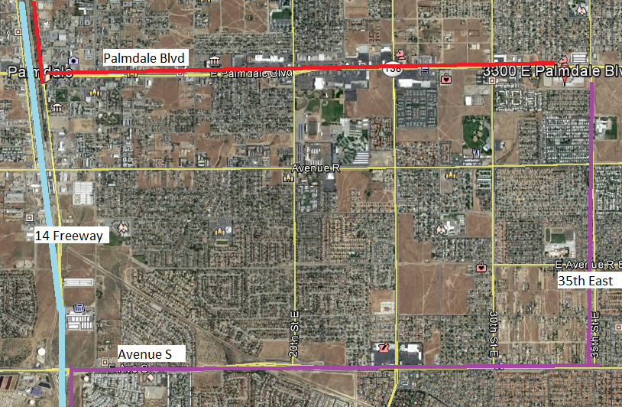

Parking & Drop off
Park anywhere in the TPAA parking lot. You can drop off team stuff in the drop-off loop on the south side of campus. (Picture is out of date. Construction is done)
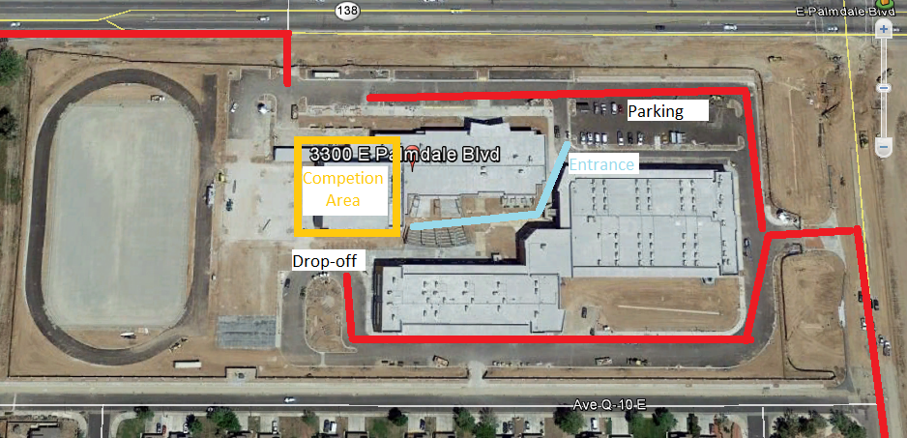

JUDGE TIMES
Time | Panel 1 | Panel 2 | Panel 3 | Panel 4 | Panel 5
 | Judges:
8:00 - 8:15 | 4344  Rickrollers | 5011  BotSquad | 5285  RoboKnights | 5325  The Muses | 5363  YULA
8:15 - 8:30 | 5380  ElectroMedics Red | 7227  Scoprion Robotics | 7328  I.C.E. | 7372  Norbots | 8396  Secret Team
8:30 - 8:45 | 9074  Robo-Scorpions | 9600  YULA Girls | 9777  Reauxbatons | 9836  Electrometics Gold | 10187  Desert Sting
8:45 - 9:00 | 11213  Mustangs | 11504  Xenon | 13116  i.am.College Track BH | 13256  Mechanika | 13273  MilkenKnights MS1
9:00 - 9:15 | 13276  MilkenKnights MS3 | 13281  MilkenKnights MS2 | 13641  YULA Boys - JV | 14193  Mann UCLA TechBots | 14645  MounTECH Lions
9:15 - 9:30 | 14802  LancerTech | 14921  AlphaOmega

INSPECTION TIMES

8:00 - 8:30 AM |  | 8:30 - 9:00 AM |  | 9:00 - 9:30 AM
13273 | MilkenKnightsMS1 | 4344 | Rickrollers | 9074 | Robo-Scorpions
13276 | MilkenKnightsMS3 | 5011 | Bot Squad | 9600 | YULA Girls
13281 | MilkenKnightsMS2 | 5285 | Robo Knights | 9777 | Reauxbatons
13641 | YULA Boys - JV | 5325 | The Muses | 9836 | ElectroMedics Gold
14193 | Mann UCLA TechBots | 5363 | YULA | 10187 | Desert Sting
14645 | MounTECH Lions | 5380 | ElectroMedics Red | 11213 | Mustangs
14802 | LancerTech | 7227 | Scorpion Robotics | 11504 | Xenon
14921 | AlphaOmega | 7328 | I. C. E. | 13116 | i.am College Track BH
13256 | Mechanika | 7372 | Norbots | 8396 | Secret Team

