Welcome to the
LA/SoCal FIRST® Tech Challenge
Monrovia Inter-League Tournament
Leagues C1-E
Sunday February 10, 2019
VOLUNTEERS!
Thank you for volunteering at the upcoming LA/SoCal FIRST® Tech Challenge Inter-League Tournament! This event can only be a success with the support of volunteers such as you, and for that we are very thankful! Please see the details below to help you prepare for the event.
NOTE -- please call or text Event Manager for the day, Patrick Brophy (951-232-2272) if you are ill, lost, or late the day of the event, or if your plans change before the event. We do not have abundant extra volunteers, so we need to know as soon as possible any changes so that we can adjust roles accordingly. At the same time, we don’t want you to come to the event ill...so let us know!
See the attachment that lists the volunteer assignments. You may have more than one, as some roles have different time shifts throughout the day. We still have holes for some jobs - if you have people who can volunteer let us know!
VOLUNTEER REGISTRATION AND TRAINING
Training is VERY important to make sure everyone has a great experience. There are a few steps and resources before you show up at the event:
- VIMS: All volunteers need to register via VIMS. For all adults, this includes Youth Protection screening, which may take up to 7 days, so please register in VIMS at least a week before the event -- and sooner is even better. You will get your Assignment in VIMS, as well as through emails and other messages. Once assigned, you will receive information to Schoology and training.
- Schoology: Most positions have required training. Materials and tests this year are found by role in Schoology. Please log in, review the material, and take a test (if required). Volunteer applies to role through their www.firstinspires.org account. Within 24 hours, volunteer will receive an email from FTCTrainingSupport@firstinspires.org with instructions on how to join the Schoology course. (If a volunteer has applied to 5 different roles and they will receive a separate email for each role. There are courses for 18 roles, 9 roles have certification tests). See end of email for individual access codes.
- Forum Spaces: Lastly, for the more complicated positions -- Judge, Technical (FTA, CSA, etc), Scorekeeper, Robot Inspector, and Referee -- there are additional Forum spaces just for your role to get up-to-the-day experiences from other regions. The forum is located in Schoology for that position.
- One page ‘cheat sheets’ !!- go to the google link and find your job for a QUICK review of your job. (feel free to print) https://drive.google.com/drive/u/0/folders/1aCwy_aE6-hjc6sJj9QMIGi8uCxCgupVg
If you are having difficulty with these tools, please contact Patrick.

EVENT LOCATION
The tournament will be held at Monrovia High School in Monrovia, CA, which is located north of the 210 Freeway between the 110 and 605 Freeways. (If you have any problems the day of the event, please call or text Miriam at (626) 841-1956)
Monrovia High School
845 W. Colorado Blvd.
Monrovia, CA 91016

If you are late or have any problems the day of the event, please call Patrick Brophy (951-232-2272).

DIRECTIONS
From Highway 210, take exit 33 (Huntington Drive), turn right onto Huntington, turn right onto 5th, turn right onto Colorado, turn left on Madison. The school is located on the corner of Colorado and Madison.

PARKING
Enter the school using the driveways off Madison Ave. There will be a ‘drop off loop’ for cars to stop and drop off robots at the front of the Event Center. After drop off, please park in one of the designated areas (see map and look for signs).

GENERAL INFORMATION
The competition will take place in the Event Center (northwest side of the property off of Madison). The Pit will be set up also at the Event Center. Judging will be in the science building (south of the Pits). The competition area and the Pit are spacious.
We will be running a 28-team One-Division tournament with 2 fields on site. All teams from each League are invited to their appropriate ILT and there are no eliminations at this point. At the ILT, there will be engineering notebooks to hand in, all the judging categories will be awarded, Compass and Promote Videos will be open, and Dean’s Award candidates will be recognized.
If you have accumulated game points from League meets, it will come into play for ILT Alliance selections. At the ILT, 10 of your top 15 matches will be in the scoring system. At the end of the ILT Qualifying matches, your 5 scores will be added to the scoring system. The highest total of these points from the 15 matches will determine the top alliance captain, next alliance captain, and so on.
The top teams (as determined by the Game Manual advancement criteria) will advance to the Los Angeles Championship Tournament. These teams will be announced on the following Robot Tuesday.

SUNDAY TENTATIVE SCHEDULE (which may shift based on day’s events)
7:00 AM Volunteer Check
7:30 AM Pits and Check-In Open
8:00 AM Judging, HW and Field Inspections begin
8:00 AM Check-In Closes
9:30 AM Driver Meeting
10:00 AM Opening Ceremonies
10:30 AM Qualifying Matches Begin
12:00 PM Lunch
12:30 PM Qualifying Matches Resume
2:30 PM Alliance Selection
3:00 PM Semi Final Matches Begin
5:00 PM Awards Ceremony
6:00 PM Event ends (tentative time)
6-8:00 PM Breakdown/ load up Storage POD
VOLUNTEER CHECK-IN
The Volunteer Room opens at 7:00 am (see Star on map). Please check the volunteer assignments to see what time you need to check in.
We ask all volunteers check-in at the Volunteer Table first (starred on map). You can then check your name off the attendance sheet. If you know a team that is competing (e.g., from your school, on the team, parent of a team member, mentor), please sign a Conflict of Interest Form (on the check-in desk). Your volunteer lead will be told of the Conflict, and may shift your location to reduce apparent conflicts.
Most roles will have assigned shirts or vests, which you will receive when you check in. Referees and Judges will have specialty shirts assigned that they will need to return at the end of the event. Volunteers will receive a yellow safety vest for the event that will be returned.
Please wear closed toe shoes. These are required for both the Pit Area and Competition Area, so without them you will not be able to enter most of the facility, so we ask all volunteers to wear closed toe shoes all day.
Safety glasses - If you are volunteering in a position in the pit area or on the field, safety glasses or ANSI side shields are required. If you have your own pair, please bring them. If not, we have some glasses to loan out, though they are not elegant. Prescription glasses must have ANSI certified side shields or safety glasses over them. (Duct tape or paper attached to the side of glasses is not sufficient.) If you like, there are some nice safety glasses and side shields at anyone ranging from Home Depot to Amazon if you would like some nice gear for the day. Bling is optional
Volunteer Check in Schedule - Volunteers are asked to arrive between 7am and 9am, depending on their role.
- 7:00am - Team Registration, Robot Inspectors, Field inspectors, Pit Manager, Pit Runners, Judges, Crowd Control, Volunteer Check-in, Judge Runners FTAs
- 8am - Head Ref, Referees, Photography
- 9am - Scorekeepers, Field Managers, Field Reset, Queuers, Emcee, Game Announcer, Disk Jockey
ALL PUHSD student volunteers need to arrive no later than 7:30, regardless of the assigned job.
VOLUNTEER BREAK ROOM
The Volunteer Break room will have continental breakfast, coffee, and snacks. Lunch will be in the volunteer room at the designated lunch time on the schedule.

CLOSING CEREMONIES
For those volunteers who will finish your assignment before closing ceremonies, please feel free to stay and watch the final competitions and awards. It’s a very exciting close to a long day. We also welcome additional volunteers to break the equipment into its travel totes and containers at the end of the event so we can all go home sooner.
Once again, thank you for volunteering!

Schoology Login:https://app.schoology.com/login
Access Codes:
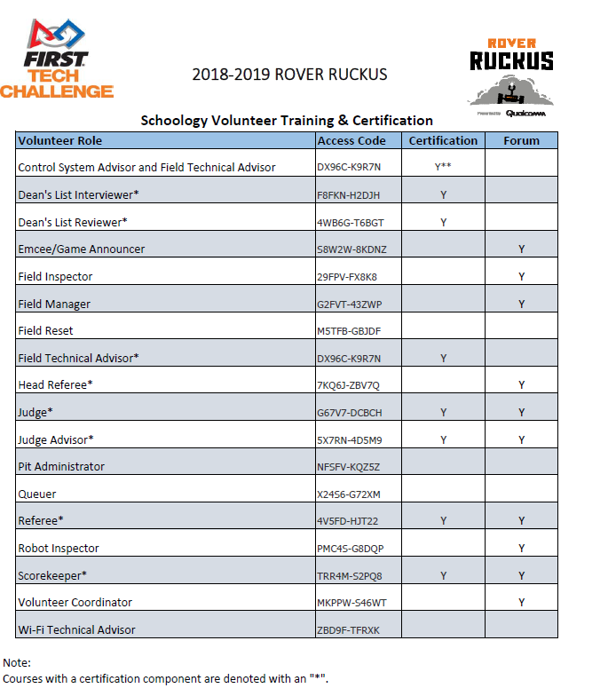

Campus Maps and Information
Monrovia HS

