Welcome to the
LA/SoCal FIRST® Tech Challenge
Palmdale Inter-League Tournament
Leagues D and V
Saturday, February 16th, 2019

VOLUNTEERS!
Thank you for volunteering at the upcoming LA/SoCal FIRST® Tech Challenge Inter-League Tournament! This event can only be a success with the support of volunteers such as you, and for that we are very thankful! Please see the details below to help you prepare for the event.
NOTE -- please call or text Patrick @ 951-232-2272) if you are ill, lost, or late the day of the event, or if your plans change before the event. We do not have abundant extra volunteers, so we need to know as soon as possible any changes so that we can adjust roles accordingly. At the same time, we don’t want you to come to the event ill...so let us know!
See the attachment that lists the volunteer assignments. You may have more than one, as some roles have different time shifts throughout the day.
VOLUNTEER REGISTRATION AND TRAINING
Training is VERY important to make sure everyone has a great experience. There are a few steps and resources before you show up at the event:
- VIMS: All volunteers need to register via VIMS. For all adults, this includes Youth Protection screening, which may take up to 7 days, so please register in VIMS at least a week before the event -- and sooner is even better. You will get your Assignment in VIMS, as well as through emails and other messages. Once assigned, you will receive information to Schoology and training.
- Schoology: Most positions have required training. Materials and tests this year are found by role in (I updated this section) Schoology. Please log in, review the material, and take a test (if required). Volunteer applies to role through their www.firstinspires.org account. Within 24 hours, volunteer will receive an email from FTCTrainingSupport@firstinspires.org with instructions on how to join the Schoology course. (If a volunteer has applied to 5 different roles and they will receive a separate email for each role. There are courses for 18 roles, 9 roles have certification tests). See end of email for individual access codes.
- Forum Spaces: Lastly, for the more complicated positions -- Judge, Technical (FTA, CSA, etc), Scorekeeper, Robot Inspector, and Referee -- there are additional Forum spaces just for your role to get up-to-the-day experiences from other regions. The forum is located on the Schoology space for that position.
If you are having difficulty with these tools, please contact Patrick.
EVENT LOCATION
NOTE: Access to the school from Palmdale Boulevard MIGHT be closed due to construction. The only access is from R and 35th East. We are hopeful that the road will be open by the ILT, but it is not guaranteed. Also remember, this is a new location for the PAA.

From Highway 14 North - Exit Palmdale Blvd and go east. Turn right on 30th East. Turn left on Avenue R. Turn left on 35th East. The school will be at the end of the street to the left.

From Highway 14 South - Exit Avenue S and go east. Turn left on 35th East. Drive until Palmdale Blvd and the school will be on the left.
e school will be on the left.

If you are late or have any problems the day of the event, please call Patrick @ 951-232-2272).
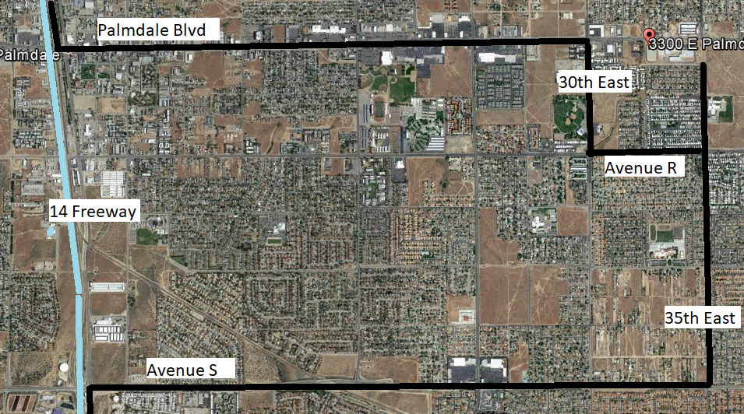

PARKING
Cars will come in through the entrance on 35th East. Teams can use the drop-off loop on the south side of campus. Visitor and team parking is available on the north side of campus.

GENERAL INFORMATION
The competition will take place in the gym. The pit and practice area will be set up in the cafeteria. Inspections will be in the gym. Judging rooms will be in the T building on the south side of campus. We try to maximize the amount of space teams have in the pit, but we expect it to be very busy, especially in the morning.
If you haven’t been part of a FIRST event, you’ll be in for a treat. We also need your help in that endeavor. FIRST has a great practice called Gracious Professionalism. It combines the best feelings of competitive sports and extreme support for those around you -- a very positive environment. You will see teams helping other teams all day, even ones that they are about to compete with! We need your help in setting the tone. We try to be friendly to ensure a positive experience for all teams, and to create a fair, consistent experience. We also share with our leads the great things that are going on so those teams with Gracious Professionalism can be recognized and appreciated as well.
We will be running a 19-team One-Division tournament with 2 fields on site. At the ILT, there will be engineering notebooks to hand in, all the judging categories will be awarded, along with Compass and Promote Video awards. Dean’s Award candidates will be interviewed via Skype during a set appointment time before the event.
The top teams (as determined by the Game Manual advancement criteria) will advance to the Los Angeles Championship Tournament. These teams will be announced on the following Robot Tuesday.

TENTATIVE SCHEDULE (which may shift based on day’s events)
SATURDAY
7:00 AM Volunteer Check
7:30 AM Pits and Check-In Open
8:00 AM Judging, HW and Field Inspections begin
8:00 AM Check-In Closes
9:30 AM Driver Meeting
10:00 AM Opening Ceremonies
10:30 AM Qualifying Matches Begin
12:00 PM Lunch
12:30 PM Qualifying Matches Resume
2:30 PM Alliance Selection
3:00 PM Semi Final Matches Begin
5:00 PM Awards Ceremony
6:00 PM Event ends (tentative time)
6-7:00 PM Cleanup/ set up for Sunday
VOLUNTEER CHECK-IN
The Volunteer Room opens at 7:00 am (see Star on map). Please check the volunteer assignments to see what time you need to check in.
We ask all volunteers check-in at the Volunteer Table first (starred on map). You can then check your name off the attendance sheet. If you know a team that is competing (e.g., from your school, on the team, parent of a team member, mentor), please sign a Conflict of Interest Form (on the check-in desk). Your volunteer lead will be told of the Conflict, and may shift your location to reduce apparent conflicts.
Most roles will have assigned shirts or vests, which you will receive when you check in. Referees and Judges will have specialty shirts assigned that they will need to return at the end of the event. Volunteers will receive a yellow safety vest for the event that will be returned.
Please wear closed toe shoes. These are required for both the Pit Area and Competition Area, so without them you will not be able to enter most of the facility, so we ask all volunteers to wear closed toe shoes all day.
Safety glasses - If you are volunteering in a position in the pit area or on the field, safety glasses or ANSI side shields are required. If you have your own pair, please bring them. If not, we have some glasses to loan out, though they are not elegant. Prescription glasses must have ANSI certified side shields or safety glasses over them. (Duct tape or paper attached to the side of glasses is not sufficient.) If you like, there are some nice safety glasses and side shields at anyone ranging from Home Depot to Amazon if you would like some nice gear for the day. Bling is optional
Volunteer Check in Schedule - Volunteers are asked to arrive between 7am and 9am, depending on their role.
- 7:00am - Team Registration, Robot Inspectors, Field inspectors, Pit Manager, Pit Runners, Judges, Crowd Control, Volunteer Check-in, Judge Runners FTAs
- 8am - Head Ref, Referees, Photography
- 9am - Scorekeepers, Field Managers, Field Reset, Queuers, Emcee, Game Announcer, Disk Jockey
VOLUNTEER BREAK ROOM
The Volunteer Break room will have continental breakfast, coffee, and snacks. Lunch will be in the volunteer room at the designated lunch time on the schedule.

CLOSING CEREMONIES
For those volunteers who will finish your assignment before closing ceremonies, please feel free to stay and watch the final competitions and awards. It’s a very exciting close to a long day. We also welcome additional volunteers to break the equipment into its travel totes and containers at the end of the event so we can all go home sooner.
Once again, thank you for volunteering!

Schoology Access Codes
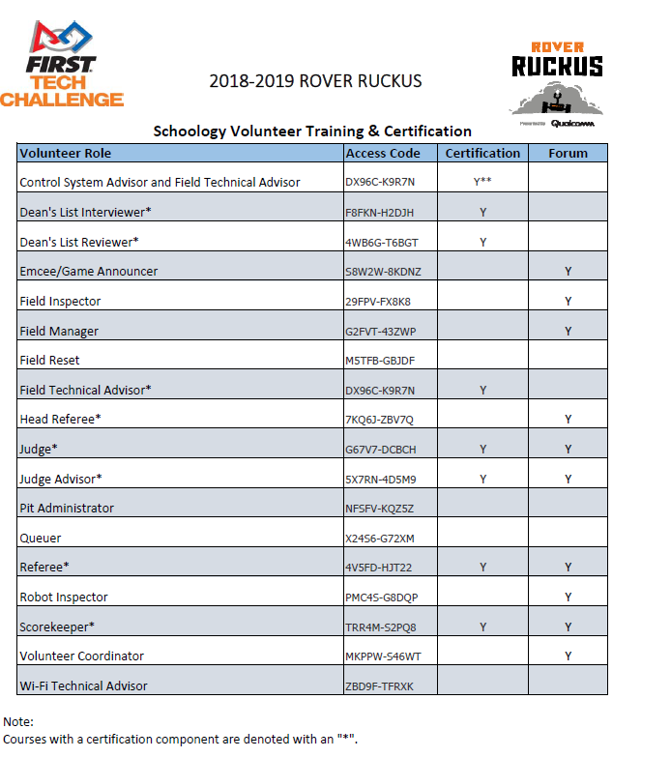

Campus Maps and Information
Perris High School
175 E. Nuevo Rd.
Perris, CA 92570

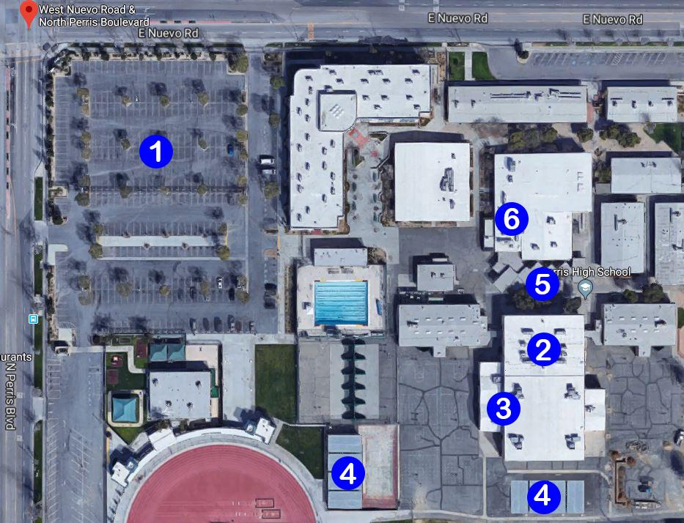

LEGEND
1 | Parking
2 | Check-In & Pit Area
3 | Competition Area
4 | Judging Rooms
5 | Food Area
6 | Volunteer Room

