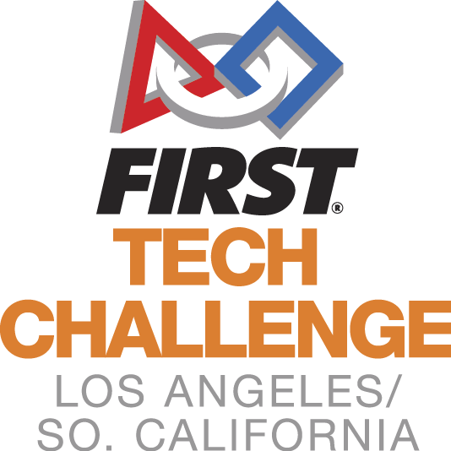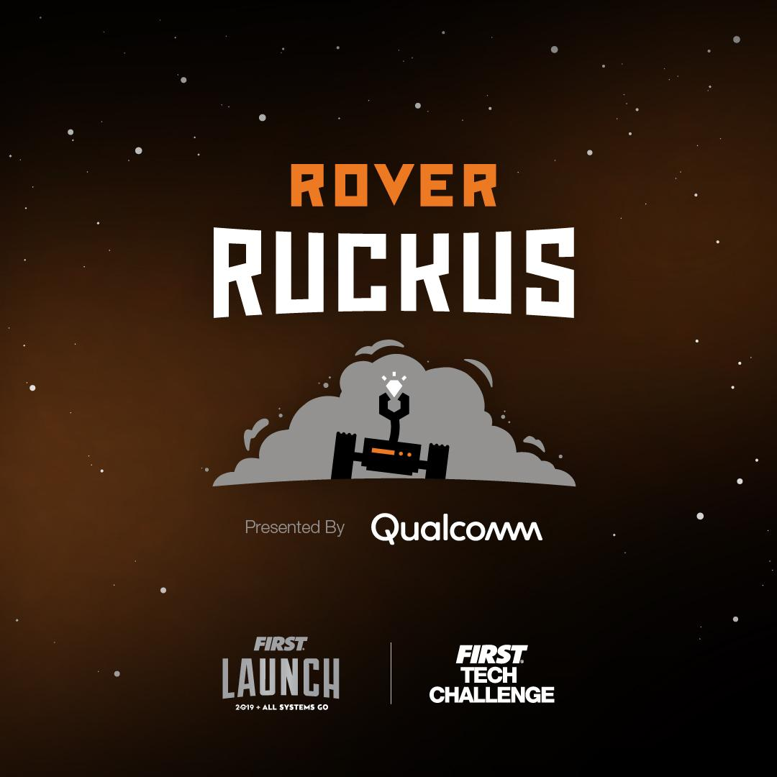
Welcome to the
LA/SoCal FIRST® Tech Challenge
2019 Regional Championships
Saturday, March 9th, 2019

WELCOME TEAMS! Welcome Teams! We’re at our last (and biggest) event of the season: the 2019 LA/SoCal Regional Championships! Congratulations on advancing from one of our six InterLeague Tournaments (ILTs) to the 2019 Los Angeles/Southern California Regional Championship! We will be celebrating the top 48 teams in the region as they compete for top honors and 7 advancements to World Championships in Houston, TX. We are so proud of your accomplishments and look forward to your participation in our event. Below is additional information to help you to prepare:
Please share this information with your team members

PLEASE SHARE THIS INFORMATION WITH ALL DRIVERS -- IF YOU ARE RUNNING LATE OR LOST THE DAY OF THE EVENT, PLEASE CALL … Theresa Klemme 949-356-8674

KEY ITEMS for THIS EVENT:
- Limit of 10 persons/team in the pits. Must stay within the 3x5ft pit table provided.
- Maximum of 15 students per team will be enforced
- ANSI Safety glasses or ANSI side shields will be required of all students and adults in the pits, queuing, or competition area. No exceptions, so buy now for your visitors and family
- Both Robot and Field Self-Inspection Form MUST be completed by the team to complete Check-in
- Engineering Notebooks (with team name and number on the front) and Control Award Forms will also be submitted at Check-in
- Pit power will be at share tables against the wall and not at your pit table.
- Please provide 2 volunteers per team to help run the event
- March 1st, 2019 – Compass and Promote Submission due before Midnight
- March 9th, 2019 – Competition Day!!!

EVENT LOCATION
The tournament will be held at Monrovia High School in Monrovia, CA, which is located north of the 210 Freeway between the 110 and 605 Freeways. (If you have any problems the day of the event, please call or text Miriam at (626) 841-1956)
Monrovia High School
845 W. Colorado Blvd.
Monrovia, CA 91016

DIRECTIONS
From Highway 210, take exit 33 (Huntington Drive), turn right onto Huntington, turn right onto 5th, turn right onto Colorado, turn left on Madison. The school is located on the corner of Colorado and Madison.

PARKING
Enter the school using the driveways off Madison Ave. There will be a ‘drop off loop’ for cars to stop and drop off robots at the front of the Event Center. After drop off, please park in one of the designated areas (see map and look for signs).

GENERAL INFORMATION
DIVISIONS -- We will be running a Two-Division Tournament, with which a few teams may not be familiar. In order to accommodate the number of teams participating, we will have 4 fields on site -- with two division competitions (24 teams each) running simultaneously. For the day, you will be assigned to either Green or Orange Division, and will only compete with the teams in your division through all qualification matches, semi-finals, and division finals. The two division-winning alliances will then play each other at day’s end to determine the overall tournament Champions.
Divisions will be selected ranking teams by OPR (Offensive Power Rating) and alternating by division to better balance the competition. We will be revealing the final Championship roster after Feb. 18. What is an OPR? You can see a FTC-wide calculation and list at http://ftcstats.org/qualifiers.html, and a nice text description at https://blog.thebluealliance.com/2017/10/05/the-math-behind-opr-an-introduction/.
We will start fresh with your game points; meaning none of your League Meets or Interleague results will be carried forward.
There will be engineering notebooks to hand in, all the judging categories will be awarded, Compass and Promote Videos will be open, and Dean’s Award candidates will be recognized.
The top teams (as determined by the Game Manual advancement criteria) will advance to Worlds Championship Tournament in Houston. These teams will be announced on the following Robot Tuesday.
SCHEDULE -- Since we will be operating out of three different buildings, it is important that you are aware of your staging times for judging, inspection, and competition matches in order for the tournament to stay on schedule. If you are unsure of where and when you should be next, please ask any of our volunteers who will be present in all three areas. A map can be found at the end of this document, and signs will be posted throughout campus.
TENTATIVE SCHEDULE (which may shift based on day’s events)
SATURDAY
7:00 AM – Pit & Check-in opens
8:00 AM – Judging & Inspections begin
8:00 AM – Check-in Closes
9:30 AM - Inspection Ends
10:00 AM – Drivers’ Meeting
10:15 AM – Opening Ceremonies
10:45 AM – Qualifying matches begin
12:15 PM – Lunch
1:00 PM – Qualifying matches resume (with next 4 matches returning by 12:50 pm)
3:00 PM – Alliance selection
3:30 PM – Semi-final matches begin
4:30 PM -- Finals matches begin (Division, and then Championship)
6:00 PM – Awards ceremony
7:00 PM - Event ends (tentative time)
We may end sooner or later than these times, so please make arrangements to stay at least until 7 pm. -- if events shift later -- and stay through the Awards Ceremonies. Teams are expected to stay through the entire event, even if it runs late. If your team cannot stay for any reason, please let the Pit Manager, Jennifer Anderson, know of your team’s departure. If you have questions contact Theresa Klemme at TFKlemme@gmail.com or 949-356-8674 (cell).

TEAM CHECK-IN
Check-in on Saturday morning is between 7:30 a.m. – 8:00 a.m. in the pit area. All teams MUST check in by 8:30 a.m. or they will not be given qualifying matches. Please note – the judging and inspection schedules are pre-assigned and start prior to the end of check-in. You must check in prior to your scheduled judging or inspection time slot. If your team is delayed for any reason, please call the phone number above as soon as you know to keep the event management informed.

Bring to Check-In:
- FTC Consent form for each team member and mentor. We highly recommend completing the consents using your FIRSTInspires.org mentor Dashboard with your team and printing it out to bring to the event.
**Remember, no more than 15 team members are permitted per team and max 10 people/team in the Pits.**
- Both Self-Inspection Robot and Field Inspection COMPLETED before Check-In -- Teams are required to conduct a self-inspection of their Robot and submit the self-completed Robot Inspection forms at Check-in and Robot Inspection (Appendix, Game Manual 1)
- If you plan to be evaluated for the Control Award, please complete the control award form (in the Game Manual 1) and submit at registration.
- Engineering Notebook -- which is required for many of the awards -- review your book against award requirements as you add your finishing touches. NAME and TEAM NUMBER needs to be on the front cover. Your book will not be evaluated without this requirement filled.
- Safety glasses for your entire team and any guests. Please have them out and ready to put on before entering the Pit Area or Queues. Prescription glasses must have ANSI-certified side shields or safety glasses over them. Duct tape or paper attached to the side of glasses is not sufficient. Safety glasses for parents and guests has been an issue in the past; please plan appropriately and bring extra glasses and side shields.
Please wear closed toe shoes and eye protection. Closed toe shoe are required for both the Pit Area and Competition Area, so without them you will not be able to enter most of the facility. We ask all team members to wear closed toe shoes all day. If visitors are planning to see you in the PIT, they should be wearing closed toed shoes and eye protection as well.

INSPECTION (PLEASE READ)
Inspections will begin at 8:00 a.m and end prior to the start of Opening Ceremonies. Teams will be pre-assigned a timeslot and emailed to you no later than March 1st. Do not miss your timeslot. If you do, we cannot guarantee that you will get through inspection prior to the start of matches. You may not compete without having passed both Robot AND Field Inspection.

A copy of the Inspection Checklists that will be used can be downloaded from the Game Manual on FIRST Website, Appendix B and C. Please review these prior to coming to the event to ensure that your Inspection process goes smoothly.
JUDGING
Judging interviews will begin at 8:00 am and end by the Drivers Meeting. Teams will be pre-assigned a timeslot, emailed to you at least one week prior to the event. Do not miss your timeslot. All of your team members are welcome to attend the judging interview, just remember the time is 10 minutes and manage your time appropriately. A team can, but is not required to, have up to a 5-minute rehearsed presentation to share with the judges. This would be part of your 10 minute interview. If you do not want to give a practiced presentation, the judges will ask questions as they have in the past during the 10 minutes.
Up to 2 mentors or coaches can accompany the team at the judging interviews, but only to view the process and not to speak or interact. The judges will also be visiting the Pit as part of the judging process and it is recommended you have a team member at your booth (excluding lunch time and until Alliance selection).
Compass and Promote Video Nominations are due no later than Friday, March 1st 11:59 pm. Follow the link below to the Google Form to submit to: https://docs.google.com/forms/d/1QehMDh8wkMi0iY98dqyjMh_rDmW5JigqCMPAyXkegIc/viewform?edit_requested=true. You must use the link, which tracks your submission and connects it to key information we need. Please do not email your videos to Committee Members. Nomination links sent after the deadline will not be considered. The nomination must be in the form of a YouTube, Vimeo, or other publicly available site and must be downloadable. No private videos, please. Videos are no longer than 60 seconds and you must show written approval to use the music. You can use a video previously submitted at an ILT.

Congratulations to all of our Dean’s List Semi-Finalists, who have been interviewed from our six LA/SoCal ILTs. We will announce the four regional Finalists winners during the Award Ceremony at the Championship. Those winners’ submissions and interviews will be submitted for consideration for the Dean’s List Awards at the World Championship in April. If you have questions, please contact Theresa Klemme at TFKlemme@gmail.com or 949-356-8674 (cell).

Gracious Professionalism at Competition
“Gracious Professionalism is part of the ethos of FIRST. It's a way of doing things that encourages high-quality work, emphasizes the value of others, and respects individuals and the community. With Gracious Professionalism, fierce competition and mutual gain are not separate notions. Gracious professionals learn and compete like crazy, but treat one another with respect and kindness in the process.” -- FIRST Vision and Mission

Our teams have shown abundant Gracious Professionalism all season so far. Thank you!!! We would like to remind teams that all participants (students, mentors, parents, spectators, and volunteers) to be conscious of the overall mission of FIRST. We will always encourage friendly competition but anything deemed malicious to teams, spectators, or volunteers and/or obstructive to the progress of the event will have repercussions that may affect the entire affiliated team. So please remind your parents, friends, siblings, and others to help us with Gracious Professionalism at all times. Please also remind guests and team members that (a) they can’t save seats in the bleachers per Game Manual Part 1.

COMMEMORATIVE SHIRTS
We are excited to again have a print-on-site company who can create your own Commemorative T-Shirt designed just for this event -- printed while you wait/play. If you would like to purchase a T-Shirt, you can place an order in the morning for pick up later in the day. There are other robot images available and additional additional items to print on such as sweatshirts and canvas bags. Prices vary depending on the item. Students will want to bring extra funds to buy the T-shirts and/or sweatshirts.

ADVANCEMENT TO WORLDS in HOUSTON
We anticipate advancing 7 teams to WORLDS April 17-20, Houston , TX. We will use the Advancement Criteria in the Game Manual and plan to announce officially in Robot Tuesday the following week. Event invitations will be emailed to primary mentors from FIRST, the host organization. BE AWARE that things will move very quickly if you advance. You will need to RSVP quickly, turn in your Promote and Compass videos quickly, and pay $2000 to FIRST fairly quickly. You will need to make flight and plane reservations very quickly.

MONROVIA: FOOD, TECH SHOPPING, AND LODGING OPTIONS
Enjoy Monrovia! This was home to Upton Sinclair and the first home of the company that became McDonalds. Monrovia is a quaint town, started in the late 1800s, with lots of cute restaurants and places to relax. Teams will be coming in from all over the Region, from Kern County to South Orange County out through Palmdale, Perris, and Lancaster. Teams may be seeking food for lunch and other resources. Some teams might need . . . mechanical parts?

Hardware and Electronics
Missing something important? Gracious Professionalism might end up with parts you need from other teams, but if you need to find a missing wire or tool, here are some suggestions:
- Drone N Hobbies (NEW!), 941 W. Foothill Blvd. Monrovia, CA (1 minute) - Sat 10am-6pm
- Orchard Supply, 725 W Huntington Dr, Monrovia (2 minutes) - Sat. 7am-9pm
- Home Depot, 1625 South Mountain Avenue, Monrovia (8 minutes) - Sat. 5am-11pm
- Wal*Mart, 1600 Mountain Ave, Duarte (8 minutes) - Sat. 9am-12am
- Best Buy, 1470 Mountain Ave, Duarte (8 minutes) - Sat. 10am-9pm
- Harbor Freight, 3660 East Foothill Boulevard, Pasadena (10 minutes) - Sat. 8am-8pm

Restaurants
There will be great opportunities to buy food onsite, supporting Monrovia’s robotics booster organization, and two food trucks for your dining pleasure. You’ll be able to buy coffee and breakfast-y stuff after your team checks in as well.

But Monrovia has abundant places if you want to grab coffee or breakfast when you hit town, or to eat with your team before you head home. Here’s some suggestions:

Coffee or Breakfast:
- Starbucks Drive-Through (NEW!), right at Madison and Foothill, 860 West Foothill Blvd., Monrovia (2 minute walk -- no need to move your car) - opens 5 am!
- Denny’s, 7 Huntington Drive, Arcadia (4 minute drive) - open 24 hours!
- McDonalds, 480 W Huntington Dr, Monrovia (3-minute drive) - open 24 hours!
- Burger King, 354 W Huntington Dr, Monrovia (4-minute drive) - open 6am-12am Saturdays
- Subway, 119 W. Foothill Blvd, #B, Monrovia (626-301-0903) (4-minute drive) - open 7am Saturdays
- T-Burgers, 226 West Foothill Boulevard, Monrovia (3-minute drive) - open 7am-10pm Saturdays

Food During the Day or Before the Drive Home:
- Papa John’s Pizza, 1090 Huntington Drive, Mountain Vista Plaza Shopping Center, Duarte (8-minute drive)
- Little Caesars Pizza, 418 W Foothill Blvd, Monrovia (3-minute drive)
- Paco’s Mexican Food (dinner), 200 East Foothill Boulevard, Arcadia (3-minute drive)
- Rigo’s Mexican Food (dinner), 457 West Foothill Boulevard, Monrovia (3-minute drive)
- In-and-Out Burgers, 420 N Santa Anita Ave, Arcadia (4-minute drive)
- Panda Express, 682 Huntington Dr, Monrovia (2-minute drive)
- Chili's Grill & Bar, 630 W Huntington Dr, Monrovia (3-minute drive)
- Blaze Pizza, 108 W Foothill Blvd, Monrovia (3-minute drive)
- Starlight Express Chinese Food, 120 W Foothill Blvd, Monrovia (3-minute drive)
- Smashburger, 602 Huntington Dr, Monrovia (3-minute drive)
- Chipotle, 608 W Huntington Dr, Monrovia (3-minute drive)
- MOOYAH Burgers, Fries & Shakes, 116 W. Foothill Blvd, Suite A-7, Monrovia (3-minute drive)
- Wendy’s, 190 W Foothill Blvd, Monrovia (3-minute drive) - Open 9am-3am

Please note - the cooking or selling of food at this event by anyone other than the tournament hosts is not allowed.

Hotels
Planning to come in early to not drive in the early morning hours? You can find TripAdvisor listings at http://www.tripadvisor.com/Hotels-g32729-Monrovia_California-Hotels.html.

Here are a few hotel suggestions:
- Doubletree by Hilton Hotel, 924 West Huntington Drive, Monrovia, CA 91016
- Extended Stay America, 930 South 5th Avenue, Monrovia, CA 91016
- Quality Inn, 1125 E. Huntington Dr., Monrovia, CA 91016
- Courtyard by Marriott, 700 West Huntington Drive, Monrovia, CA 91016

KEY DATES
- Friday, February 22: Look for email with assigned inspection and judging times
- Friday, March 1st: Promote and Compass award submissions due
  - Submissions must be completed at: http://bit.ly/LAFTC18-ChampVideo
- Saturday, March 9th: Competition Day!

Any other questions, please reach out to community@firsttechsocal.org or tfklemme@gmail.com.
See you on the 9th!
Your Regional Committee

JUDGING SCHEDULE
do not miss your Judge time!

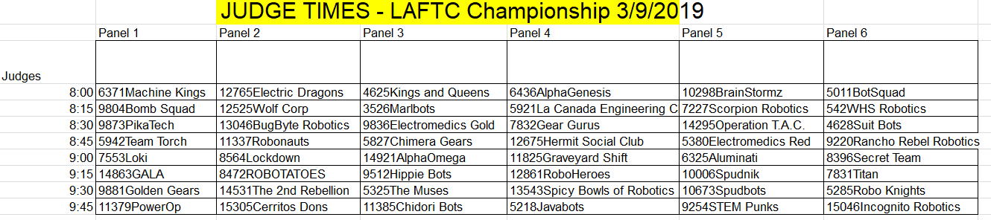

INSPECTION SCHEDULE
if you miss this time you can fit into the other slots. DO not Miss judging time!

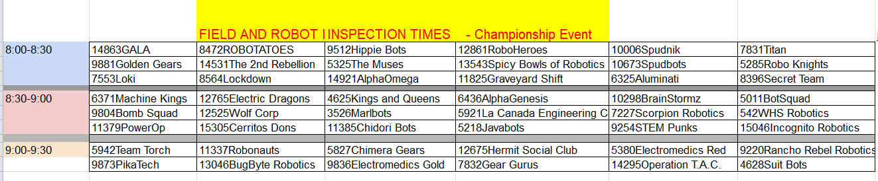

MAP
