Welcome to the
LA/SoCal FIRST® Tech Challenge
2019 Regional Championships
Saturday, March 9th, 2019
VOLUNTEERS!
We’re at our last (and biggest) event of the season: the 2019 LA/SoCal Regional Championships! Thank you for volunteering at the upcoming LA/SoCal FIRST® Tech Challenge Regional Championship! We will be celebrating the top 48 teams in the region as they compete for top honors and 7 advancements to World Championships in Houston, TX. This event can only be successful with the support of volunteers like you, and for that we are very thankful! Please see the details below to help you prepare for the event.
NOTE -- please call or text Miriam Childers at (626)841-1956 or Theresa Klemme at (949) 356-8674 if you are ill, lost, or late the day of the event, or if your plans change before the event. We do not have an abundance of extra volunteers, so we need to know changes as soon as possible so we can adjust roles accordingly. At the same time, we don’t want you to come to the event ill...so let us know!
Assignments are at the end of this document - please check.
We will have two Divisions - Orange/Odyssey and Green/Galileo and you have been assigned to a color. Please check the Team Division assignments and if you have a conflict and need to be moved to the other Divison, let me know.

VOLUNTEER REGISTRATION AND TRAINING
Training is VERY important to make sure everyone has a great experience. There are a few steps and resources before you show up at the event:
- VIMS: All volunteers need to register via VIMS. https://www.firstinspires.org/ways-to-help/volunteer For all adults, this includes Youth Protection screening, which may take up to 7 days, so please register in VIMS at least a week before the event -- and sooner is even better. You will get your Assignment in VIMS, as well as through emails and other messages. Once you sign up, even before you are assigned, you will receive information to Schoology and training. (Watch your email!)
- Schoology: Most positions have required training. Materials and tests this year are found by role in Schoology. Please log in, watch the game video (if you have not already seen it), review the material, and take a test (required for certain roles). The Schoology link will include the manual, a Q+A forum and training videos. Please review all the documents.
- Forum Spaces: Lastly, for the more complicated positions -- Judge, Technical (FTA, CSA, etc), Scorekeeper, Robot Inspector, and Referee -- there are additional Forum spaces just for your role to get up-to-the-day experiences from other regions. The forum is located on the Schoology space for that position.
If you are having difficulty with these tools, please contact Theresa Klemme at tfklemme@gmail.com.

EVENT LOCATION
Our event will take place at Monrovia High School in Monrovia, CA, which is located north of the 210 Freeway between the 110 and 605 Freeways.
Monrovia High School
845 W. Colorado Blvd.
Monrovia, CA 91016

DIRECTIONS
From Highway 210, take exit 33 (Huntington Drive), turn right onto Huntington, turn right onto 5th, turn right onto Colorado, turn left on Madison. The school is located on the corner of Colorado and Madison.

PARKING
Enter the school using the driveways off Madison Ave. Please park in one of the designated areas (see map and look for signs). Additional parking is located on the southern part of the campus, also on Madison Ave.

GENERAL INFORMATION
The Competition Area will be in the Event Center (northwest side of the property, off of Madison). The Pit will be set up in the South Gym (south of the Event Center). Judging will be in the science building (south of the Pits). The Competition Area and the Pit are spacious, though will be filled with 48 teams and their fans -- so plan accordingly.
We will be running a Two-Division tournament, which a few teams may not be familiar with. In order to accommodate the number of teams participating, we will have 4 fields on site -- with two competitions, (appx 25 teams each) running simultaneously.
If you haven’t been part of a FIRST event, you’ll be in for a treat. FIRST has a great practice called Gracious Professionalism. It combines the best feelings of competitive sports and extreme support for those around you -- a very positive environment. You will see teams helping other teams all day, even ones that they are about to compete with! We need your help in setting the tone. We try to be friendly to ensure a positive experience for all teams, and to create a fair, consistent experience. We also share with our leads the great things that are going on so those teams with Gracious Professionalism can be recognized and appreciated as well.
TENTATIVE SCHEDULE (which may shift based on day’s events)
SATURDAY (03/09/2019)
6:30 AM - Event Organizers, Hospitality, and Traffic Control Volunteers Arrive
7:00 AM – Volunteer Check in for MOST roles -- see information for your own position
7:00 AM - Pit & Check-in opens
8:00 AM – Judging & Inspections begin
8:00 AM – Check-in Closes
9:30 AM - Inspection Ends
10:00 AM – Drivers’ Meeting
10:15 AM – Opening Ceremonies
10:45 AM – Qualifying matches begin
12:15 PM – Lunch
1:00 PM – Qualifying matches resume (with next 4 matches returning by 12:50 pm)
3:00 PM – Alliance selection
3:30 PM – Semi-final matches begin
4:30 PM -- Finals matches begin (Division, and then Championship)
6:00 PM – Awards ceremony
7:00 PM - Event ends (tentative time)
7:00-8PM Breakdown/ load up Storage POD

Please note we would like all the volunteers to stay for Awards and Closing Ceremonies, so please be flexible with your time in case we run late.
VOLUNTEER CHECK-IN
The Volunteer Room opens at 7:00 am (see map).You will receive an email with your check-in time. . We ask all volunteers go to the Volunteer check-in room first. You can then check your name off the attendance sheet. If you know a team that is competing (e.g., from your school, on the team, parent of a team member, mentor), please sign a Conflict of Interest Form (attached to email; print and bring with you). Your volunteer role/position may be rearranged to reduce potential conflicts.
For this event, each volunteer will receive a special volunteer T-shirt. Judges and Referees will still wear their respective shirts but will receive a commemorative event shirt as well. NOTE: If you would like to purchase additional T-shirts beyond your one free shirt, there will be an on-site Printing Company, Fine Designs, that will print our custom design on T-Shirts, sweatshirts, canvas bags, and more.
Please wear closed toe shoes. These are required for both the Pit Area and Competition Area, so without them you will not be able to enter most of the facility, so we ask all volunteers to wear closed toe shoes all day.
Safety Glasses: If you are volunteering in a position in the pit area or on the field, safety glasses or ANSI side shields are required. If you have your own pair, please bring them. If not, we have some glasses to loan out, though they are not elegant. Prescription glasses must have ANSI-certified side shields or safety glasses over them. (Duct tape or paper attached to the side of glasses is not sufficient.) There are some nice safety glasses and side shields for purchase from Home Depot or Amazon if you would like some nice gear for the day.
Volunteer Check in Schedule - Volunteers are asked to arrive between 7am and 9am, depending on their role.
- 7:00am - Team Registration, Robot Inspectors, Field inspectors, Pit Manager, Pit Runners, Judges, Crowd Control, Volunteer Check-in, Judge Runners FTAs
- 8:00am - Head Ref, Referees, Photography
- 9:00am - Scorekeepers, Field Managers, Field Reset, Queuers, Emcee, Game Announcer, Game Room, Disk Jockey

VOLUNTEER BREAK ROOM
The check-in room will have breakfast, coffee, and snacks. It also will be the location to pick up your lunch. Please see the map at the back of the document for the location. We will have people in and out all day, so you may want to leave any valuables at home instead of leaving them in the Break Room or other location.

CLOSING CEREMONIES
For those volunteers who will finish your assignment before closing ceremonies, please feel free to stay and watch the final competitions and awards; it is a real treat to watch the final matches and see the students receive judged awards -- a very exciting close to a long day! We also welcome additional volunteers to break the equipment into its travel totes and containers at the end of the event so we can all go home sooner.
Once again, thank you for volunteering!

Volunteer Positions:
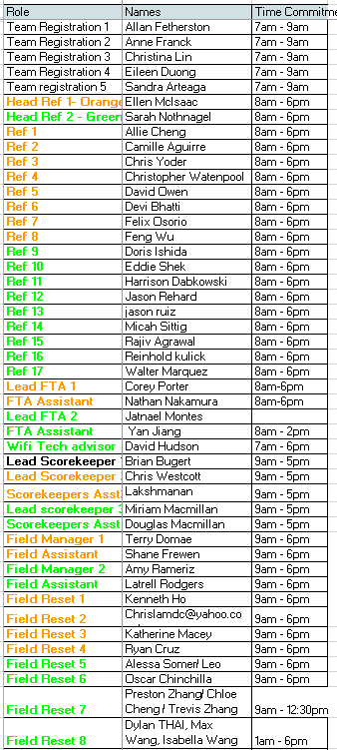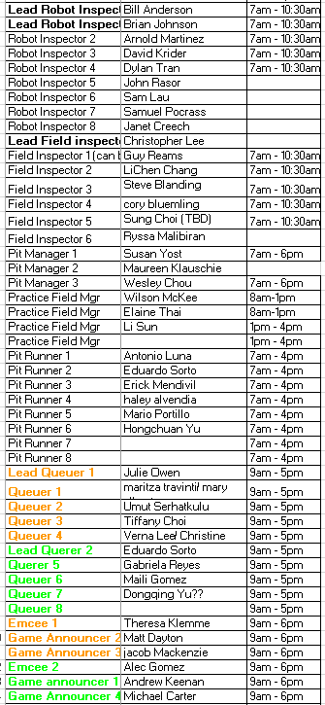

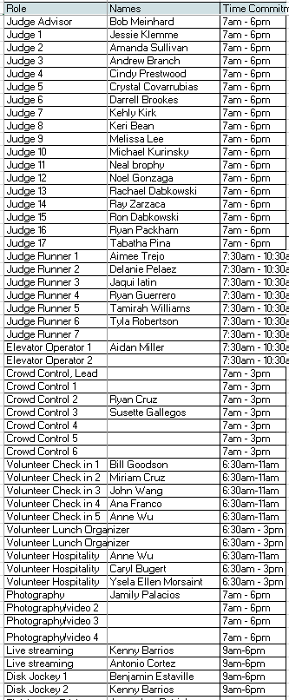

SCHOOLOGY CODES
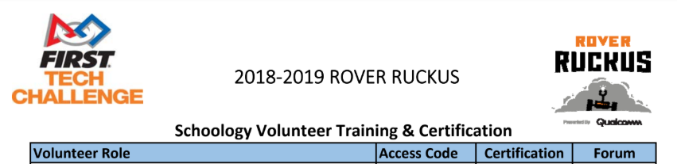
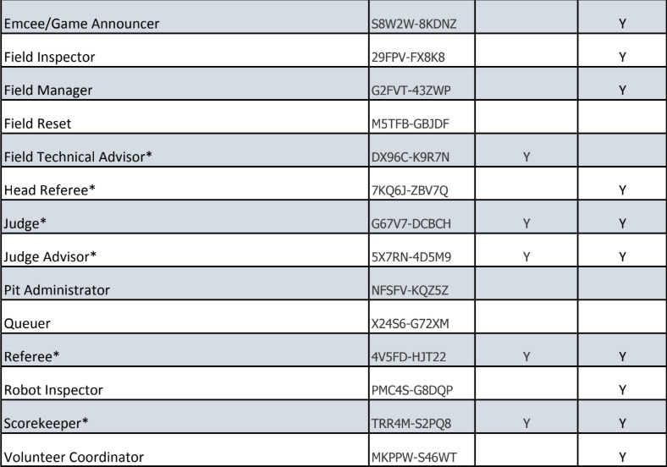

Campus Maps and Information
Monrovia High School
845 W. Colorado Blvd.
Monrovia, California 91016

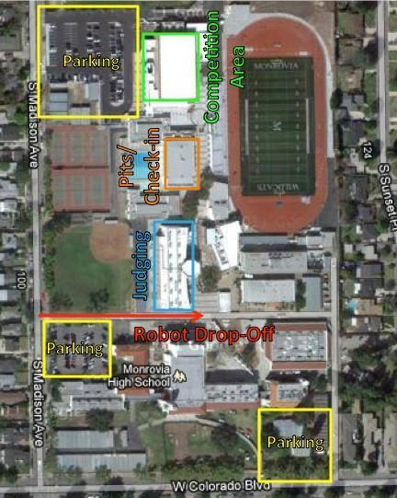
Volunteer Check-in
and Breakroom

